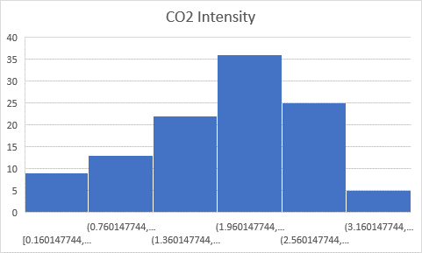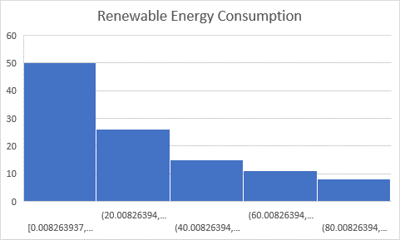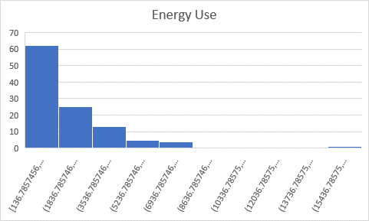

**Summary Statistics Table**



**Confidence Interval(95%)**



**What fraction of the sample has a CO2 Intensity less than your assigned country?**

The Z-score is 0.883778. About 81% of the sample has a CO2 Intensity less than Ecuador.

**What fraction of the sample has renewable energy consumption that is less than your assigned country?**

The Z-score is -0.224250175 . About 41% of the sample has renewable energy consumption less than Ecuador.

**What fraction of the sample has energy use that is less than your assigned country?**

The Z-score is -0.418786662. About 34% of the sample has renewable energy consumption less than Ecuador.

The correlation between Energy use and Renewable Energy Consumption is -0.50. Therefore, there exists a negative, moderate correlation between Energy use and Renewable Energy.

Why does there exist a moderate correlation between the two variables? Could it have been due to the presence of the other variables or, perhaps, the two variables themselves – this would imply that there is some randomness affecting one or both variables?

Hypothesis: There exists some randomness within one of the variables.